1. Fffffff
2. 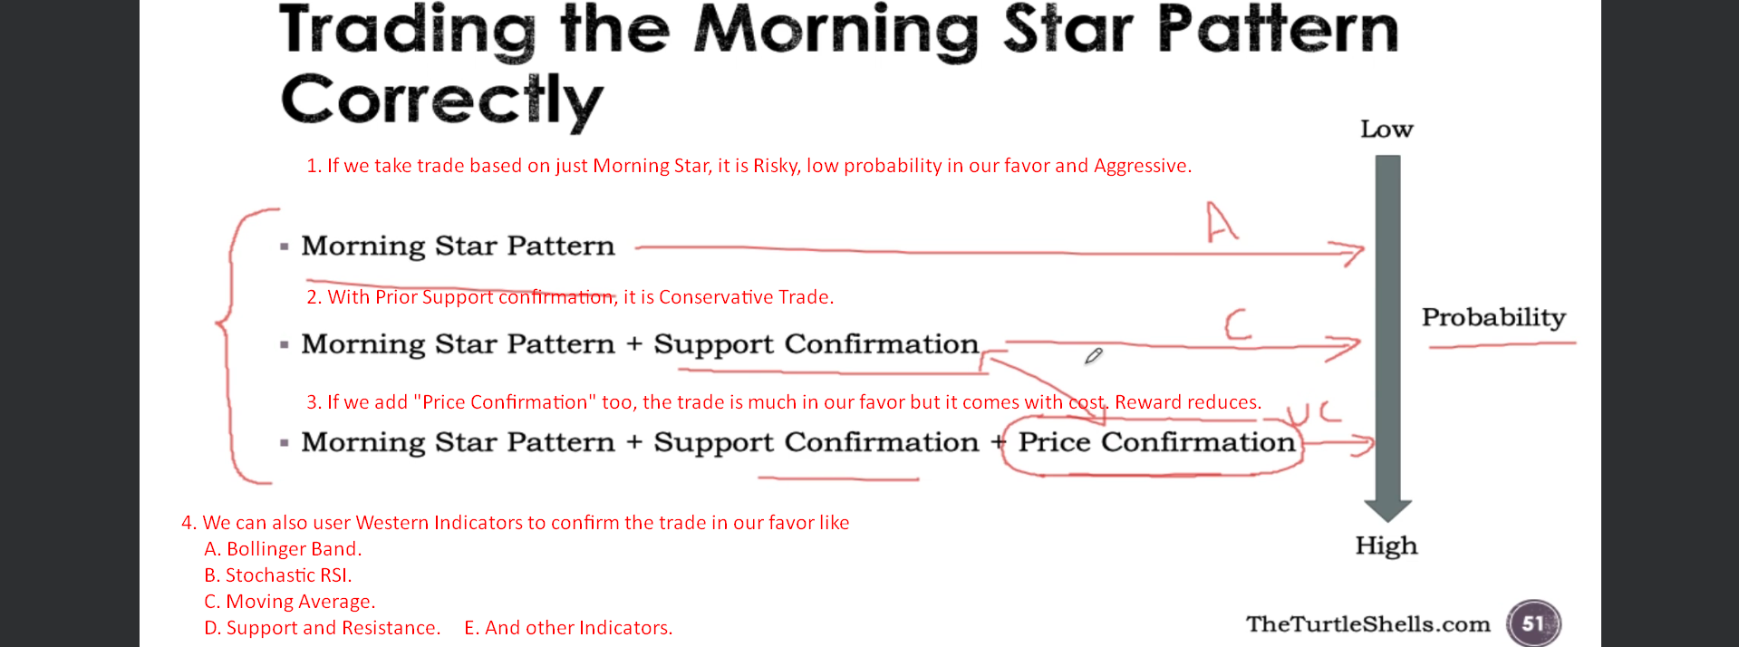
3. Let’s take an example:
4. The bigger the timeframe is, the more is the probability that the trade will work in our favor.  
   The bigger the timeframe, the lesser the confirmation, we need.
5. 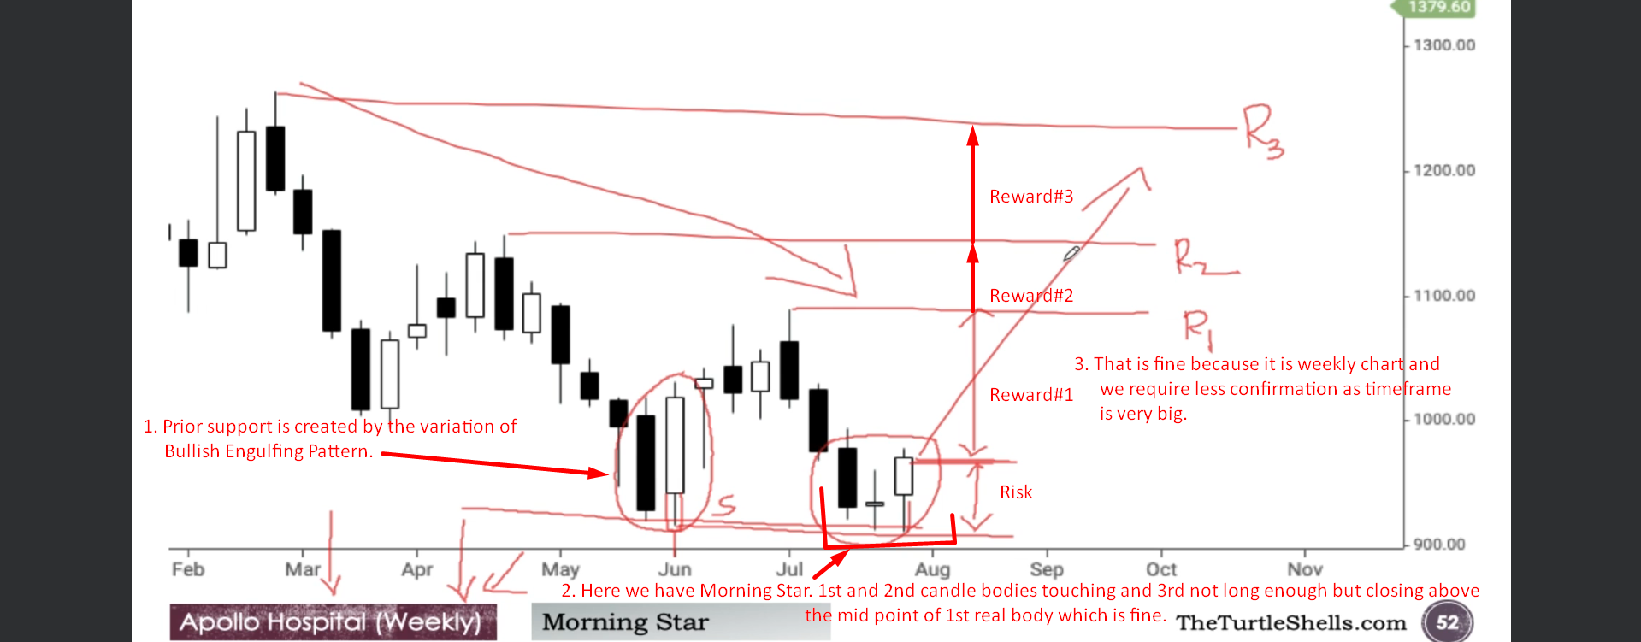
6. 